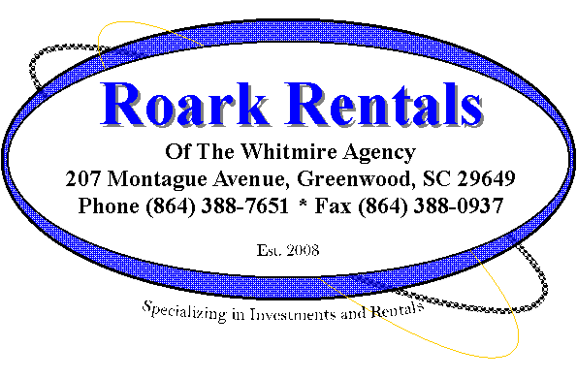
Direct Deposit Agreement Form

Roark Rentals of TWA

Authorization Agreement
I hereby authorize Roark Rentals of TWA to initiate automatic deposits to my account at the financial institution named below. I also authorize Roark Rentals of TWA to make withdrawals from this account in the event that a credit entry is made in error.
Further, I agree not to hold Roark Rentals of TWA responsible for any delay or loss of funds due to incorrect or incomplete information supplied by me or by my financial institution or due to an error on the part of my financial institution in depositing funds to my account.
This agreement will remain in effect until Roark Rentals of TWA receives a written notice of cancellation from me or my financial institution, or until I submit a new direct deposit form to the Payroll Department.
Please allow up to two payment periods for your Direct Deposit to take effect. During this time you will receive all payments in the mail. Pending unforeseen issues; all Direct Deposits post into your account the 3rd FULL week of every month.

Account Information
Name of Financial Institution:
Routing Number:
Account Number: |  |  |  | Checking |  | Savings

Signature
Authorized Signature (Primary): |  |  |  |  | Date:
Authorized Signature (Joint): |  |  |  |  | Date:
Please attach a voided check or deposit slip and return this form to Roark Rentals of TWA.
